**JAVA SWING BASED – College Network Hardware Database - SQL CONNECTIVITY USING JDBC**

*A*

*Report*

*Submitted in partial fulfillment of the Requirements for the award of the Degree of*

**BACHELOR OF ENGINEERING IN**

**INFORMATION TECHNOLOGY**

**By**

### Jiba Nafees Fathima<1602-20-737-017>

**Under the guidance of Ms B. Leelavathy**



### Department of Information Technology Vasavi College of Engineering (Autonomous) (Affiliated to Osmania University) Ibrahimbagh, Hyderabad-31

**2020-2021**

BONAFIDE CERTIFICATE

This is to certify that this project report titled

***‘Ayush Hospital Finder’***

is a project work of  **Jiba Nafees Fathima** bearing roll no. 1602-20-737-017 who carried out this project under my supervision in the IV semester for the academic year 2020- 2021

Signature Signature

External Examiner Internal Examiner

# ABSTRACT

In this project, we have to create a database where it has the details of hardware devices which are in use in the college.This database is useful for a college where they can see all the details of hardware devices which are used in each department of college .To implement this database records and to display all the data on the screen we need to build this database with details of hardware devices (like hub,switches,router..etc),department and college as the tables in the database . To build this database, we are using Run SQL for the backend and java for the frontend part.

# Requirement Analysis

## List of Tables:

* City
* Patient
* Hospital

## List of Attributes with their Domain Types:

College

* + Cityname varchar2(20)
  + pincode number(8)
  + first varchar(20)

Patient

* + firstname varchar(20)
  + lastname varchar(20)
  + age number(3)
  + gender varchar2(20)
  + contact number(10)
  + disease varchar2(20)

Hospital

* + Hospitalname varchar(10)
  + intime varchar(20)
  + outtime varchar(20)
  + patientrate varchar(20)
  + address varchar2(20)
  + demographics varchar2(20)

# AIM AND PRIORITY OF THE PROJECT

To create a **Java GUI-based** desktop application that connects college network hardware database. It calculates the hardware devices in use in the college network. It takes values like device id, device type, Status, Department id, etc through forms which are then updated in the database using JDBC connectivity

.

**DESIGN**

**Entity Relationship Diagram**

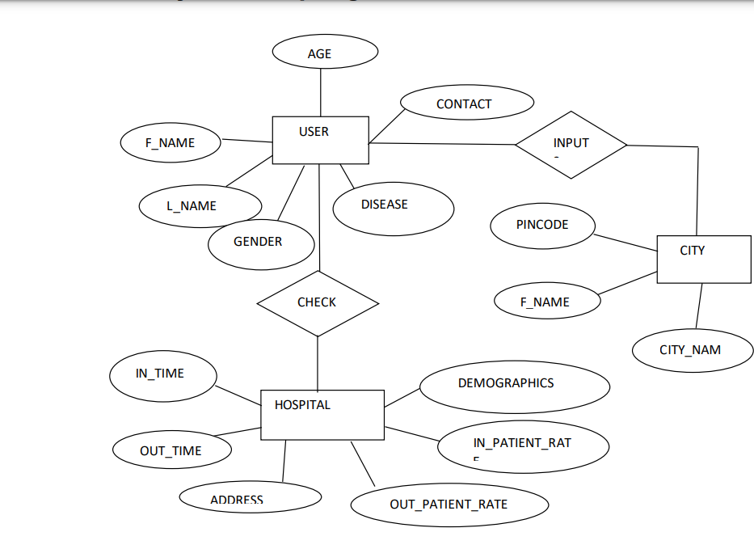

# DATABASE DESIGN

### DDL Operations

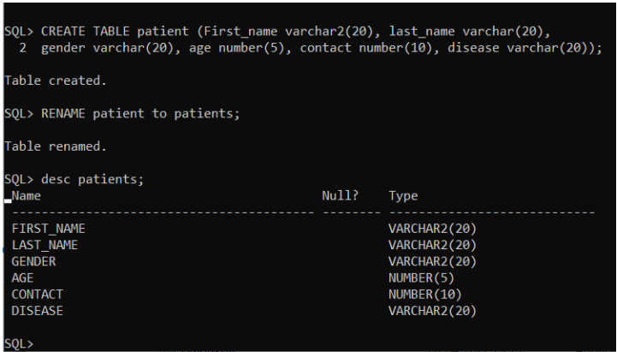

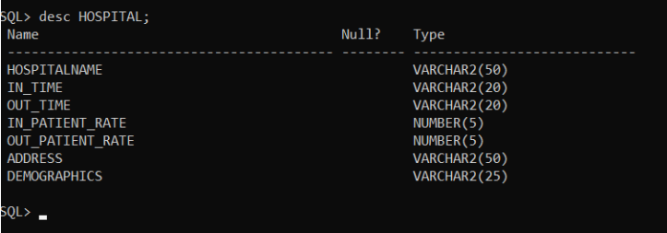

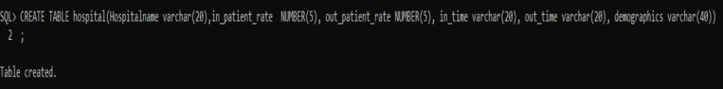

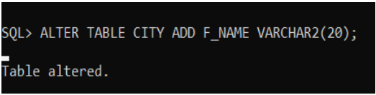

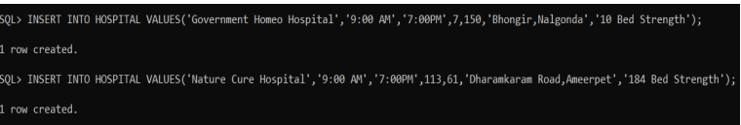

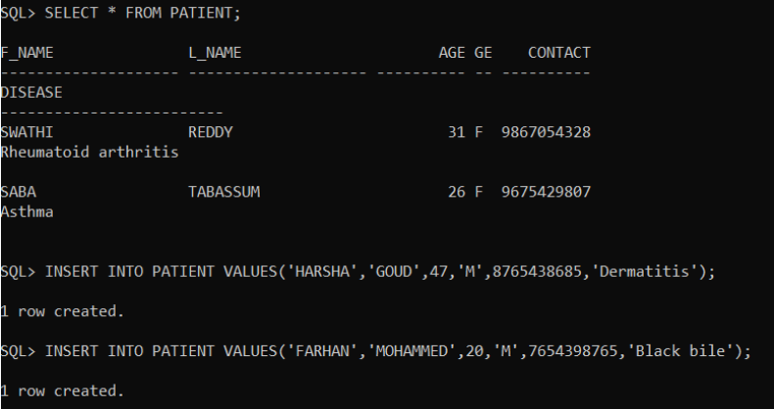

### DML Operations

# IMPLEMENTATION

### JAVA-SQL Connectivity using JDBC:

**Java Database Connectivity (JDBC)** is an application programming interface (API) for the programming language Java, which defines how a client may access a database. It is a Java-based data access technology used for Java database connectivity. It is part of the Java Standard Edition platform, from Oracle Corporation. It provides methods to query and update data in a database and is oriented towards relational databases.

The connection to the database can be performed using Java programming (JDBC API) as:

public void connectToDB()

{

try

{

connection

=

DriverManager.getConnection("jdbc:oracle:thin:@localhost:1521:xe","jiba","jiba”);

statement = connection.createStatement();

}

catch (SQLException connectException)

{

System.out.println(connectException.getMessage());

System.out.println(connectException.getSQLState()

);

System.out.println(connectException.getErrorCode());

System.exit(1);

}

}

**Front-end Programs(User Interfaces)**

**Home Page:**

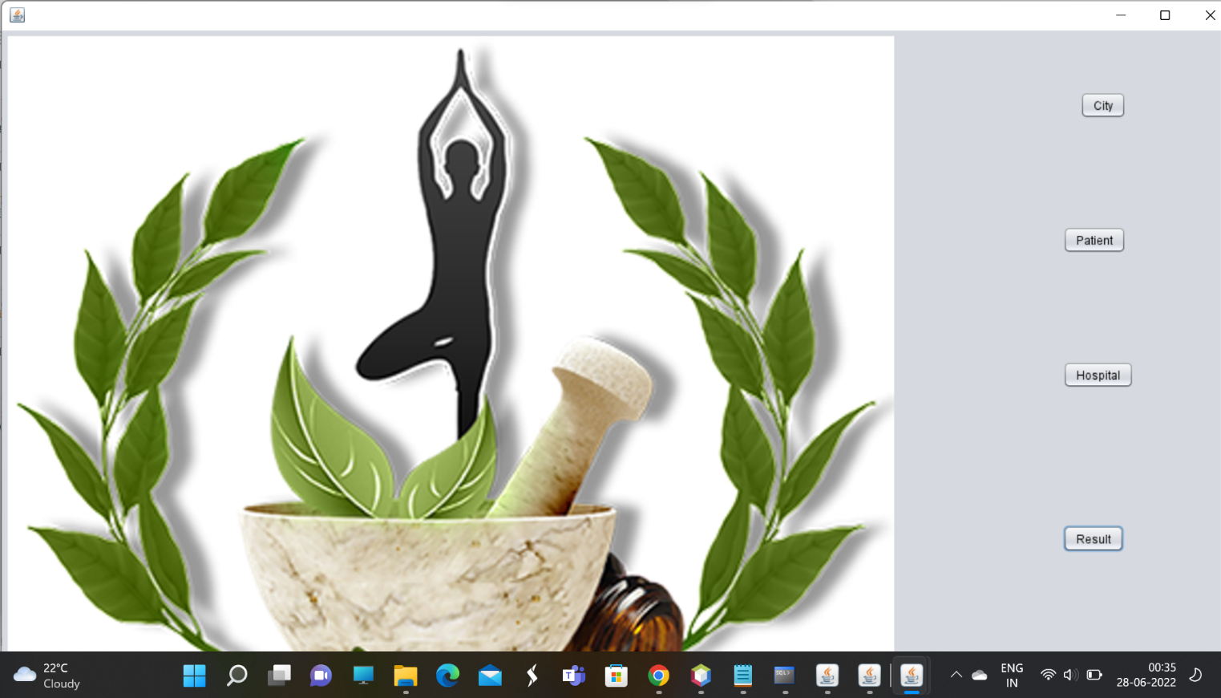

**/\***

**\* Click nbfs://nbhost/SystemFileSystem/Templates/Licenses/license-default.txt to change this license**

**\* Click nbfs://nbhost/SystemFileSystem/Templates/GUIForms/JFrame.java to edit this template**

**\*/**

**/\*\***

**\***

**\*/**

**public class Main extends javax.swing.JFrame {**

**/\*\***

**\* Creates new form Main**

**\*/**

**public Main() {**

**initComponents();**

**}**

**/\*\***

**\* This method is called from within the constructor to initialize the form.**

**\* WARNING: Do NOT modify this code. The content of this method is always**

**\* regenerated by the Form Editor.**

**\*/**

**@SuppressWarnings("unchecked")**

**// <editor-fold defaultstate="collapsed" desc="Generated Code">**

**private void initComponents() {**

**jButton1 = new javax.swing.JButton();**

**jButton2 = new javax.swing.JButton();**

**jButton3 = new javax.swing.JButton();**

**jButton4 = new javax.swing.JButton();**

**jLabel1 = new javax.swing.JLabel();**

**jPanel1 = new javax.swing.JPanel();**

**jLabel2 = new javax.swing.JLabel();**

**setDefaultCloseOperation(javax.swing.WindowConstants.EXIT_ON_CLOSE);**

**jButton1.setText("City");**

**jButton1.addActionListener(new java.awt.event.ActionListener() {**

**public void actionPerformed(java.awt.event.ActionEvent evt) {**

**jButton1ActionPerformed(evt);**

**}**

**});**

**jButton2.setText("Patient");**

**jButton2.addActionListener(new java.awt.event.ActionListener() {**

**public void actionPerformed(java.awt.event.ActionEvent evt) {**

**jButton2ActionPerformed(evt);**

**}**

**});**

**jButton3.setText("Hospital");**

**jButton3.addActionListener(new java.awt.event.ActionListener() {**

**public void actionPerformed(java.awt.event.ActionEvent evt) {**

**jButton3ActionPerformed(evt);**

**}**

**});**

**jButton4.setText("Result");**

**jButton4.addActionListener(new java.awt.event.ActionListener() {**

**public void actionPerformed(java.awt.event.ActionEvent evt) {**

**jButton4ActionPerformed(evt);**

**}**

**});**

**jLabel1.setText("jLabel1");**

**jPanel1.setLayout(new org.netbeans.lib.awtextra.AbsoluteLayout());**

**jLabel2.setIcon(new javax.swing.ImageIcon("C:\\Users\\sai suman\\Downloads\\1656356493389.png")); // NOI18N**

**jLabel2.setText("jLabel2");**

**javax.swing.GroupLayout layout = new javax.swing.GroupLayout(getContentPane());**

**getContentPane().setLayout(layout);**

**layout.setHorizontalGroup(**

**layout.createParallelGroup(javax.swing.GroupLayout.Alignment.LEADING)**

**.addGroup(layout.createSequentialGroup()**

**.addContainerGap()**

**.addComponent(jLabel2, javax.swing.GroupLayout.PREFERRED_SIZE, 925, javax.swing.GroupLayout.PREFERRED_SIZE)**

**.addGroup(layout.createParallelGroup(javax.swing.GroupLayout.Alignment.TRAILING)**

**.addGroup(layout.createSequentialGroup()**

**.addPreferredGap(javax.swing.LayoutStyle.ComponentPlacement.RELATED, javax.swing.GroupLayout.DEFAULT_SIZE, Short.MAX_VALUE)**

**.addComponent(jLabel1, javax.swing.GroupLayout.PREFERRED_SIZE, 852, javax.swing.GroupLayout.PREFERRED_SIZE))**

**.addGroup(layout.createSequentialGroup()**

**.addGap(176, 176, 176)**

**.addGroup(layout.createParallelGroup(javax.swing.GroupLayout.Alignment.LEADING)**

**.addGroup(layout.createParallelGroup(javax.swing.GroupLayout.Alignment.TRAILING)**

**.addComponent(jButton1)**

**.addComponent(jButton2))**

**.addComponent(jButton3)**

**.addComponent(jButton4))**

**.addPreferredGap(javax.swing.LayoutStyle.ComponentPlacement.RELATED, javax.swing.GroupLayout.DEFAULT_SIZE, Short.MAX_VALUE)**

**.addComponent(jPanel1, javax.swing.GroupLayout.PREFERRED_SIZE, javax.swing.GroupLayout.DEFAULT_SIZE, javax.swing.GroupLayout.PREFERRED_SIZE)**

**.addContainerGap())))**

**);**

**layout.setVerticalGroup(**

**layout.createParallelGroup(javax.swing.GroupLayout.Alignment.LEADING)**

**.addGroup(layout.createSequentialGroup()**

**.addGroup(layout.createParallelGroup(javax.swing.GroupLayout.Alignment.LEADING)**

**.addGroup(layout.createSequentialGroup()**

**.addGap(12, 12, 12)**

**.addComponent(jLabel1, 0, 0, javax.swing.GroupLayout.PREFERRED_SIZE)**

**.addGroup(layout.createParallelGroup(javax.swing.GroupLayout.Alignment.LEADING)**

**.addGroup(layout.createSequentialGroup()**

**.addPreferredGap(javax.swing.LayoutStyle.ComponentPlacement.RELATED)**

**.addComponent(jPanel1, javax.swing.GroupLayout.DEFAULT_SIZE, javax.swing.GroupLayout.DEFAULT_SIZE, Short.MAX_VALUE))**

**.addGroup(layout.createSequentialGroup()**

**.addGap(51, 51, 51)**

**.addComponent(jButton1)**

**.addGap(111, 111, 111)**

**.addComponent(jButton2)**

**.addGap(111, 111, 111)**

**.addComponent(jButton3)**

**.addGap(141, 141, 141)**

**.addComponent(jButton4)**

**.addGap(0, 0, Short.MAX_VALUE))))**

**.addGroup(javax.swing.GroupLayout.Alignment.TRAILING, layout.createSequentialGroup()**

**.addContainerGap()**

**.addComponent(jLabel2, javax.swing.GroupLayout.DEFAULT_SIZE, javax.swing.GroupLayout.DEFAULT_SIZE, Short.MAX_VALUE)))**

**.addContainerGap())**

**);**

**pack();**

**}// </editor-fold>**

**private void jButton3ActionPerformed(java.awt.event.ActionEvent evt) {**

**HospitalUI x = new HospitalUI();**

**x.show();**

**}**

**private void jButton1ActionPerformed(java.awt.event.ActionEvent evt) {**

**CityUI t = new CityUI();**

**t.show();**

**}**

**private void jButton2ActionPerformed(java.awt.event.ActionEvent evt) {**

**Patient p = new Patient();**

**p.show();**

**}**

**private void jButton4ActionPerformed(java.awt.event.ActionEvent evt) {**

**Result r = new Result();**

**r.show();**

**}**

**/\*\***

**\* @param args the command line arguments**

**\*/**

**public static void main(String args[]) {**

**/* Set the Nimbus look and feel */**

**//<editor-fold defaultstate="collapsed" desc=" Look and feel setting code (optional) ">**

**/* If Nimbus (introduced in Java SE 6) is not available, stay with the default look and feel.**

**\* For details see http://download.oracle.com/javase/tutorial/uiswing/lookandfeel/plaf.html**

**\*/**

**try {**

**for (javax.swing.UIManager.LookAndFeelInfo info : javax.swing.UIManager.getInstalledLookAndFeels()) {**

**if ("Nimbus".equals(info.getName())) {**

**javax.swing.UIManager.setLookAndFeel(info.getClassName());**

**break;**

**}**

**}**

**} catch (ClassNotFoundException ex) {**

**java.util.logging.Logger.getLogger(Main.class.getName()).log(java.util.logging.Level.SEVERE, null, ex);**

**} catch (InstantiationException ex) {**

**java.util.logging.Logger.getLogger(Main.class.getName()).log(java.util.logging.Level.SEVERE, null, ex);**

**} catch (IllegalAccessException ex) {**

**java.util.logging.Logger.getLogger(Main.class.getName()).log(java.util.logging.Level.SEVERE, null, ex);**

**} catch (javax.swing.UnsupportedLookAndFeelException ex) {**

**java.util.logging.Logger.getLogger(Main.class.getName()).log(java.util.logging.Level.SEVERE, null, ex);**

**}**

**//</editor-fold>**

**/* Create and display the form */**

**java.awt.EventQueue.invokeLater(new Runnable() {**

**public void run() {**

**new Main().setVisible(true);**

**}**

**});**

**}**

**// Variables declaration - do not modify**

**private javax.swing.JButton jButton1;**

**private javax.swing.JButton jButton2;**

**private javax.swing.JButton jButton3;**

**private javax.swing.JButton jButton4;**

**private javax.swing.JLabel jLabel1;**

**private javax.swing.JLabel jLabel2;**

**private javax.swing.JPanel jPanel1;**

**// End of variables declaration**

**}**

**City Table:**

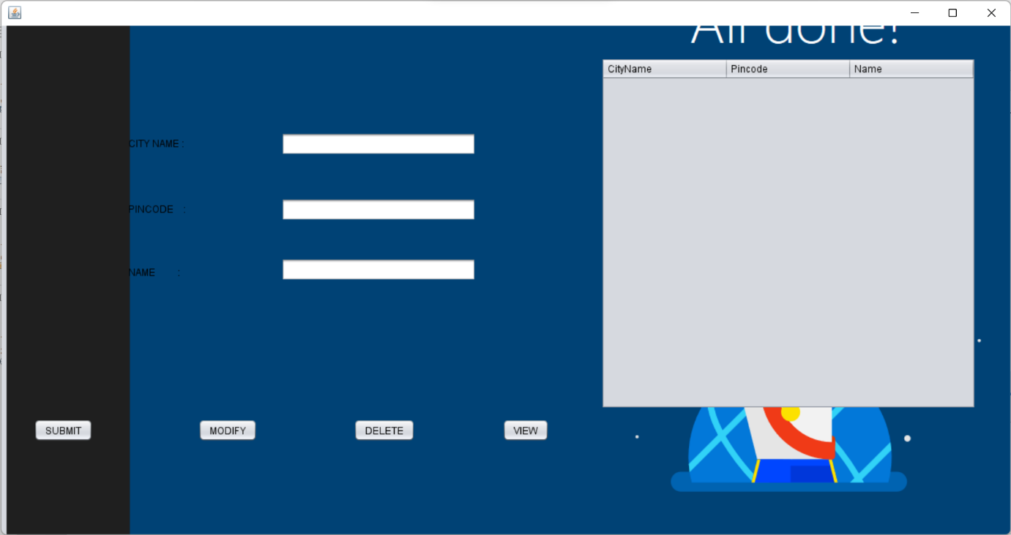

import java.sql.Connection;

import java.sql.DriverManager;

import java.sql.ResultSet;

import java.sql.Statement;

import javax.swing.JFrame;

import javax.swing.JOptionPane;

import javax.swing.*;

import javax.swing.table.DefaultTableModel;

/*

* Click nbfs://nbhost/SystemFileSystem/Templates/Licenses/license-default.txt to change this license

* Click nbfs://nbhost/SystemFileSystem/Templates/GUIForms/JFrame.java to edit this template

*/

/**

*

* @author jiba nafees

*/

public class CityUI extends javax.swing.JFrame {

/**

* Creates new form CityUI

*/

public CityUI() {

initComponents();

}

/**

* This method is called from within the constructor to initialize the form.

* WARNING: Do NOT modify this code. The content of this method is always

* regenerated by the Form Editor.

*/

@SuppressWarnings("unchecked")

// <editor-fold defaultstate="collapsed" desc="Generated Code">

private void initComponents() {

jPopupMenu1 = new javax.swing.JPopupMenu();

jPopupMenu2 = new javax.swing.JPopupMenu();

jLabel1 = new javax.swing.JLabel();

jLabel2 = new javax.swing.JLabel();

jLabel3 = new javax.swing.JLabel();

jTextField1 = new javax.swing.JTextField();

jTextField2 = new javax.swing.JTextField();

jTextField3 = new javax.swing.JTextField();

jButton1 = new javax.swing.JButton();

jButton2 = new javax.swing.JButton();

jButton4 = new javax.swing.JButton();

jScrollPane1 = new javax.swing.JScrollPane();

table = new javax.swing.JTable();

view = new javax.swing.JButton();

jLabel4 = new javax.swing.JLabel();

setDefaultCloseOperation(javax.swing.WindowConstants.EXIT_ON_CLOSE);

getContentPane().setLayout(new org.netbeans.lib.awtextra.AbsoluteLayout());

jLabel1.setText("CITY NAME :");

getContentPane().add(jLabel1, new org.netbeans.lib.awtextra.AbsoluteConstraints(154, 135, 180, -1));

jLabel2.setText("PINCODE :");

getContentPane().add(jLabel2, new org.netbeans.lib.awtextra.AbsoluteConstraints(154, 215, -1, -1));

jLabel3.setText("NAME :");

getContentPane().add(jLabel3, new org.netbeans.lib.awtextra.AbsoluteConstraints(154, 283, -1, 35));

jTextField1.addActionListener(new java.awt.event.ActionListener() {

public void actionPerformed(java.awt.event.ActionEvent evt) {

jTextField1ActionPerformed(evt);

}

});

getContentPane().add(jTextField1, new org.netbeans.lib.awtextra.AbsoluteConstraints(340, 130, 237, -1));

getContentPane().add(jTextField2, new org.netbeans.lib.awtextra.AbsoluteConstraints(340, 210, 237, -1));

jTextField3.addActionListener(new java.awt.event.ActionListener() {

public void actionPerformed(java.awt.event.ActionEvent evt) {

jTextField3ActionPerformed(evt);

}

});

getContentPane().add(jTextField3, new org.netbeans.lib.awtextra.AbsoluteConstraints(340, 283, 237, -1));

jButton1.setText("SUBMIT");

jButton1.addActionListener(new java.awt.event.ActionListener() {

public void actionPerformed(java.awt.event.ActionEvent evt) {

jButton1ActionPerformed(evt);

}

});

getContentPane().add(jButton1, new org.netbeans.lib.awtextra.AbsoluteConstraints(39, 479, -1, -1));

jButton2.setText("MODIFY");

jButton2.addActionListener(new java.awt.event.ActionListener() {

public void actionPerformed(java.awt.event.ActionEvent evt) {

jButton2ActionPerformed(evt);

}

});

getContentPane().add(jButton2, new org.netbeans.lib.awtextra.AbsoluteConstraints(239, 479, -1, -1));

jButton4.setText("DELETE");

jButton4.addActionListener(new java.awt.event.ActionListener() {

public void actionPerformed(java.awt.event.ActionEvent evt) {

jButton4ActionPerformed(evt);

}

});

getContentPane().add(jButton4, new org.netbeans.lib.awtextra.AbsoluteConstraints(428, 479, -1, -1));

table.setModel(new javax.swing.table.DefaultTableModel(

new Object [][] {

},

new String [] {

"CityName", "Pincode", "Name"

}

) {

Class[] types = new Class [] {

java.lang.String.class, java.lang.Integer.class, java.lang.String.class

};

public Class getColumnClass(int columnIndex) {

return types [columnIndex];

}

});

jScrollPane1.setViewportView(table);

getContentPane().add(jScrollPane1, new org.netbeans.lib.awtextra.AbsoluteConstraints(729, 39, -1, -1));

view.setText("VIEW");

view.addActionListener(new java.awt.event.ActionListener() {

public void actionPerformed(java.awt.event.ActionEvent evt) {

viewActionPerformed(evt);

}

});

getContentPane().add(view, new org.netbeans.lib.awtextra.AbsoluteConstraints(609, 479, -1, -1));

jLabel4.setIcon(new javax.swing.ImageIcon(getClass().getResource("/Screenshot (1).png"))); // NOI18N

jLabel4.setText("jLabel4");

getContentPane().add(jLabel4, new org.netbeans.lib.awtextra.AbsoluteConstraints(6, 0, 1221, 620));

pack();

}// </editor-fold>

private void jTextField1ActionPerformed(java.awt.event.ActionEvent evt) {

// TODO add your handling code here:

}

private void jTextField3ActionPerformed(java.awt.event.ActionEvent evt) {

// TODO add your handling code here:

}

private void jButton1ActionPerformed(java.awt.event.ActionEvent evt) {

try

{

DriverManager.registerDriver(new oracle.jdbc.driver.OracleDriver());

// Connect to Oracle Database

Connection con = DriverManager.getConnection("jdbc:oracle:thin:@localhost:1521:XE" ,"jiba","jiba");

Statement statement = con.createStatement();

// Execute a SELECT query on Oracle Dummy DUAL Table. Useful for retrieving system values

// Enables us to retrieve values as if querying from a table

String query = "INSERT INTO City VALUES(" + "'"+jTextField1.getText() + "',"+"'"+ jTextField2.getText()+"',"+"'" +jTextField3.getText() +"'"+")";

//String sqlqry="insert into customers values()"

ResultSet rs = statement.executeQuery(query);

JOptionPane.showMessageDialog(new JFrame(), "Inserted Successfully", "INFORMATION", JOptionPane.INFORMATION_MESSAGE);

/*while(rs.next()) {

//Date currentDate = rs.getDate(1); // get first column returned

//System.out.println("Current Date from Oracle is : "+currentDate);

System.out.println(rs.getString("ID") + rs.getString("AADHAR"));

}*/

rs.close();

statement.close();

con.close();

}

catch(Exception e)

{

System.out.println(e);

}

}

private void jButton2ActionPerformed(java.awt.event.ActionEvent evt) {

try

{

DriverManager.registerDriver(new oracle.jdbc.driver.OracleDriver());

// Connect to Oracle Database

Connection con = DriverManager.getConnection("jdbc:oracle:thin:@localhost:1521:XE" ,"jiba","jiba");

Statement statement = con.createStatement();

// Execute a SELECT query on Oracle Dummy DUAL Table. Useful for retrieving system values

// Enables us to retrieve values as if querying from a table

/// String query = "UPDATE INTO STUDENT VALUES(" + "'"+jTextField2.getText() + "',"+"'"+ jTextField3.getText()+"'" +")";

//String sqlqry="insert into customers values()"

String query = "UPDATE PatientUI SET firstname='" + jTextField3.getText() + "' WHERE cityname='" + jTextField1.getText() +"'";

ResultSet rs = statement.executeQuery(query);

JOptionPane.showMessageDialog(new JFrame(), "Updated Successfully", "INFORMATION", JOptionPane.INFORMATION_MESSAGE);

/*while(rs.next()) {

//Date currentDate = rs.getDate(1); // get first column returned

//System.out.println("Current Date from Oracle is6 : "+currentDate);

System.out.println(rs.getString("ID") + rs.getString("AADHAR"));

}*/

rs.close();

statement.close();

con.close();

}

catch(Exception e)

{

System.out.println(e);

}

}

private void jButton3ActionPerformed(java.awt.event.ActionEvent evt) {

try

{

DriverManager.registerDriver(new oracle.jdbc.driver.OracleDriver());

// Connect to Oracle Database

Connection con = DriverManager.getConnection("jdbc:oracle:thin:@localhost:1521:XE" ,"jiba","jiba");

Statement statement = con.createStatement();

// Execute a SELECT query on Oracle Dummy DUAL Table. Useful for retrieving system values

// Enables us to retrieve values as if querying from a table

String query = "DELETE from STUDENT where firstname = '" + jTextField1.getText() + "'";

//String sqlqry="insert into customers values()"

ResultSet rs = statement.executeQuery(query);

JOptionPane.showMessageDialog(new JFrame(), "Deleted Successfully", "INFORMATION", JOptionPane.INFORMATION_MESSAGE);

/*while(rs.next()) {

//Date currentDate = rs.getDate(1); // get first column returned

//System.out.println("Current Date from Oracle is : "+currentDate);

System.out.println(rs.getString("ID") + rs.getString("AADHAR"));

}*/

rs.close();

statement.close();

con.close();

}

catch(Exception e)

{

System.out.println(e);

}

}

private void jButton4ActionPerformed(java.awt.event.ActionEvent evt) {

try

{

DriverManager.registerDriver(new oracle.jdbc.driver.OracleDriver());

// Connect to Oracle Database

Connection con = DriverManager.getConnection("jdbc:oracle:thin:@localhost:1521:XE" ,"shruthi","kovvurss");

Statement statement = con.createStatement();

// Execute a SELECT query on Oracle Dummy DUAL Table. Useful for retrieving system values

// Enables us to retrieve values as if querying from a table

String query = "DELETE from CITY where firstname = '" + jTextField1.getText() + "'";

//String sqlqry="insert into customers values()"

ResultSet rs = statement.executeQuery(query);

JOptionPane.showMessageDialog(new JFrame(), "Deleted Successfully", "INFORMATION", JOptionPane.INFORMATION_MESSAGE);

/*while(rs.next()) {

//Date currentDate = rs.getDate(1); // get first column returned

//System.out.println("Current Date from Oracle is : "+currentDate);

System.out.println(rs.getString("ID") + rs.getString("AADHAR"));

}*/

rs.close();

statement.close();

con.close();

}

catch(Exception e)

{

System.out.println(e);

}

}

private void viewActionPerformed(java.awt.event.ActionEvent evt) {

try

{

DriverManager.registerDriver(new oracle.jdbc.driver.OracleDriver());

// Connect to Oracle Database

Connection con = DriverManager.getConnection("jdbc:oracle:thin:@localhost:1521:XE" ,"jiba","jiba");

Statement statement = con.createStatement();

// Execute a SELECT query on Oracle Dummy DUAL Table. Useful for retrieving system values

// Enables us to retrieve values as if querying from a table

String query = "SELECT * FROM City";

//String sqlqry="insert into customers values()"

ResultSet rs = statement.executeQuery(query);

// JOptionPane.showMessageDialog(new JFrame(), "City Info", "INFORMATION", JOptionPane.INFORMATION_MESSAGE);

DefaultTableModel model = (DefaultTableModel) table.getModel();

String city,pin,name;

while(rs.next())

{

city = rs.getString(1);

pin = rs.getString(2);

name = rs.getString(3);

String d[] = {city,pin,name};

model.addRow(d);

}

/*while(rs.next()) {

//Date currentDate = rs.getDate(1); // get first column returned

//System.out.println("Current Date from Oracle is : "+currentDate);

System.out.println(rs.getString("ID") + rs.getString("AADHAR"));

}*/

rs.close();

statement.close();

con.close();

}

catch(Exception e)

{

System.out.println(e);

}

}

/**

* @param args the command line arguments

*/

public static void main(String args[]) {

/* Set the Nimbus look and feel */

//<editor-fold defaultstate="collapsed" desc=" Look and feel setting code (optional) ">

/* If Nimbus (introduced in Java SE 6) is not available, stay with the default look and feel.

* For details see http://download.oracle.com/javase/tutorial/uiswing/lookandfeel/plaf.html

*/

try {

for (javax.swing.UIManager.LookAndFeelInfo info : javax.swing.UIManager.getInstalledLookAndFeels()) {

if ("Nimbus".equals(info.getName())) {

javax.swing.UIManager.setLookAndFeel(info.getClassName());

break;

}

}

} catch (ClassNotFoundException ex) {

java.util.logging.Logger.getLogger(CityUI.class.getName()).log(java.util.logging.Level.SEVERE, null, ex);

} catch (InstantiationException ex) {

java.util.logging.Logger.getLogger(CityUI.class.getName()).log(java.util.logging.Level.SEVERE, null, ex);

} catch (IllegalAccessException ex) {

java.util.logging.Logger.getLogger(CityUI.class.getName()).log(java.util.logging.Level.SEVERE, null, ex);

} catch (javax.swing.UnsupportedLookAndFeelException ex) {

java.util.logging.Logger.getLogger(CityUI.class.getName()).log(java.util.logging.Level.SEVERE, null, ex);

}

//</editor-fold>

/* Create and display the form */

java.awt.EventQueue.invokeLater(new Runnable() {

public void run() {

new CityUI().setVisible(true);

}

});

}

// Variables declaration - do not modify

private javax.swing.JButton jButton1;

private javax.swing.JButton jButton2;

private javax.swing.JButton jButton4;

private javax.swing.JLabel jLabel1;

private javax.swing.JLabel jLabel2;

private javax.swing.JLabel jLabel3;

private javax.swing.JLabel jLabel4;

private javax.swing.JPopupMenu jPopupMenu1;

private javax.swing.JPopupMenu jPopupMenu2;

private javax.swing.JScrollPane jScrollPane1;

private javax.swing.JTextField jTextField1;

private javax.swing.JTextField jTextField2;

private javax.swing.JTextField jTextField3;

private javax.swing.JTable table;

private javax.swing.JButton view;

// End of variables declaration

}

**Patient Table:**

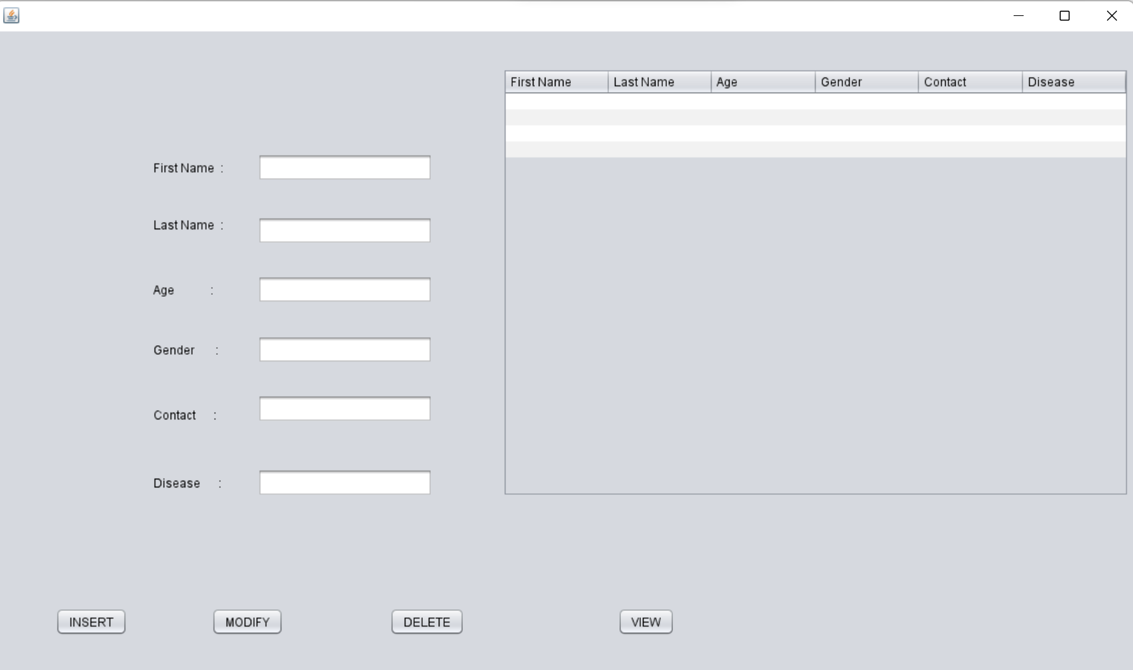

import static com.sun.xml.internal.fastinfoset.alphabet.BuiltInRestrictedAlphabets.table;

import java.sql.Connection;

import java.sql.DriverManager;

import java.sql.ResultSet;

import java.sql.Statement;

import javax.swing.JFrame;

import javax.swing.JOptionPane;

import javax.swing.table.DefaultTableModel;

/*

* Click nbfs://nbhost/SystemFileSystem/Templates/Licenses/license-default.txt to change this license

* Click nbfs://nbhost/SystemFileSystem/Templates/GUIForms/JFrame.java to edit this template

*/

/**

*

* @author sai suman

*/

public class Patient extends javax.swing.JFrame {

/**

* Creates new form Patient

*/

public Patient() {

initComponents();

}

/**

* This method is called from within the constructor to initialize the form.

* WARNING: Do NOT modify this code. The content of this method is always

* regenerated by the Form Editor.

*/

@SuppressWarnings("unchecked")

// <editor-fold defaultstate="collapsed" desc="Generated Code">

private void initComponents() {

jLabel1 = new javax.swing.JLabel();

jLabel2 = new javax.swing.JLabel();

jLabel3 = new javax.swing.JLabel();

jLabel4 = new javax.swing.JLabel();

jLabel5 = new javax.swing.JLabel();

jLabel6 = new javax.swing.JLabel();

jButton1 = new javax.swing.JButton();

jButton2 = new javax.swing.JButton();

jButton3 = new javax.swing.JButton();

jButton4 = new javax.swing.JButton();

jScrollPane1 = new javax.swing.JScrollPane();

jTable1 = new javax.swing.JTable();

jTextField1 = new javax.swing.JTextField();

jTextField2 = new javax.swing.JTextField();

jTextField3 = new javax.swing.JTextField();

jTextField4 = new javax.swing.JTextField();

jTextField5 = new javax.swing.JTextField();

jTextField6 = new javax.swing.JTextField();

setDefaultCloseOperation(javax.swing.WindowConstants.EXIT_ON_CLOSE);

jLabel1.setText("First Name :");

jLabel2.setText("Last Name :");

jLabel3.setText("Age :");

jLabel4.setText("Gender :");

jLabel5.setText("Contact :");

jLabel6.setText("Disease :");

jButton1.setText("INSERT");

jButton1.addActionListener(new java.awt.event.ActionListener() {

public void actionPerformed(java.awt.event.ActionEvent evt) {

jButton1ActionPerformed(evt);

}

});

jButton2.setText("MODIFY");

jButton2.addActionListener(new java.awt.event.ActionListener() {

public void actionPerformed(java.awt.event.ActionEvent evt) {

jButton2ActionPerformed(evt);

}

});

jButton3.setText("DELETE");

jButton3.addActionListener(new java.awt.event.ActionListener() {

public void actionPerformed(java.awt.event.ActionEvent evt) {

jButton3ActionPerformed(evt);

}

});

jButton4.setText("VIEW");

jButton4.addActionListener(new java.awt.event.ActionListener() {

public void actionPerformed(java.awt.event.ActionEvent evt) {

jButton4ActionPerformed(evt);

}

});

jTable1.setModel(new javax.swing.table.DefaultTableModel(

new Object [][] {

{null, null, null, null, null, null},

{null, null, null, null, null, null},

{null, null, null, null, null, null},

{null, null, null, null, null, null}

},

new String [] {

"First Name", "Last Name", "Age", "Gender", "Contact", "Disease"

}

) {

Class[] types = new Class [] {

java.lang.String.class, java.lang.String.class, java.lang.String.class, java.lang.String.class, java.lang.String.class, java.lang.String.class

};

public Class getColumnClass(int columnIndex) {

return types [columnIndex];

}

});

jScrollPane1.setViewportView(jTable1);

jTextField1.addActionListener(new java.awt.event.ActionListener() {

public void actionPerformed(java.awt.event.ActionEvent evt) {

jTextField1ActionPerformed(evt);

}

});

jTextField4.addActionListener(new java.awt.event.ActionListener() {

public void actionPerformed(java.awt.event.ActionEvent evt) {

jTextField4ActionPerformed(evt);

}

});

javax.swing.GroupLayout layout = new javax.swing.GroupLayout(getContentPane());

getContentPane().setLayout(layout);

layout.setHorizontalGroup(

layout.createParallelGroup(javax.swing.GroupLayout.Alignment.LEADING)

.addGroup(layout.createSequentialGroup()

.addGap(60, 60, 60)

.addComponent(jButton1)

.addGap(84, 84, 84)

.addComponent(jButton2)

.addGap(106, 106, 106)

.addComponent(jButton3)

.addGap(153, 153, 153)

.addComponent(jButton4)

.addContainerGap(javax.swing.GroupLayout.DEFAULT_SIZE, Short.MAX_VALUE))

.addGroup(layout.createSequentialGroup()

.addGap(158, 158, 158)

.addGroup(layout.createParallelGroup(javax.swing.GroupLayout.Alignment.LEADING)

.addComponent(jLabel1)

.addComponent(jLabel2)

.addComponent(jLabel3)

.addComponent(jLabel4)

.addComponent(jLabel5)

.addComponent(jLabel6))

.addGap(34, 34, 34)

.addGroup(layout.createParallelGroup(javax.swing.GroupLayout.Alignment.LEADING, false)

.addComponent(jTextField1, javax.swing.GroupLayout.DEFAULT_SIZE, 175, Short.MAX_VALUE)

.addComponent(jTextField2)

.addComponent(jTextField3)

.addComponent(jTextField4)

.addComponent(jTextField5)

.addComponent(jTextField6))

.addPreferredGap(javax.swing.LayoutStyle.ComponentPlacement.RELATED, 70, Short.MAX_VALUE)

.addComponent(jScrollPane1, javax.swing.GroupLayout.PREFERRED_SIZE, 626, javax.swing.GroupLayout.PREFERRED_SIZE)

.addContainerGap())

);

layout.setVerticalGroup(

layout.createParallelGroup(javax.swing.GroupLayout.Alignment.LEADING)

.addGroup(layout.createSequentialGroup()

.addGap(37, 37, 37)

.addGroup(layout.createParallelGroup(javax.swing.GroupLayout.Alignment.TRAILING)

.addGroup(layout.createSequentialGroup()

.addGroup(layout.createParallelGroup(javax.swing.GroupLayout.Alignment.BASELINE)

.addComponent(jLabel1)

.addComponent(jTextField1, javax.swing.GroupLayout.PREFERRED_SIZE, javax.swing.GroupLayout.DEFAULT_SIZE, javax.swing.GroupLayout.PREFERRED_SIZE))

.addGap(35, 35, 35)

.addGroup(layout.createParallelGroup(javax.swing.GroupLayout.Alignment.LEADING)

.addComponent(jLabel2)

.addComponent(jTextField2, javax.swing.GroupLayout.PREFERRED_SIZE, javax.swing.GroupLayout.DEFAULT_SIZE, javax.swing.GroupLayout.PREFERRED_SIZE))

.addGap(31, 31, 31)

.addGroup(layout.createParallelGroup(javax.swing.GroupLayout.Alignment.LEADING)

.addGroup(javax.swing.GroupLayout.Alignment.TRAILING, layout.createSequentialGroup()

.addGroup(layout.createParallelGroup(javax.swing.GroupLayout.Alignment.BASELINE)

.addComponent(jLabel3)

.addComponent(jTextField3, javax.swing.GroupLayout.PREFERRED_SIZE, javax.swing.GroupLayout.DEFAULT_SIZE, javax.swing.GroupLayout.PREFERRED_SIZE))

.addGap(32, 32, 32)

.addGroup(layout.createParallelGroup(javax.swing.GroupLayout.Alignment.BASELINE)

.addComponent(jLabel4)

.addComponent(jTextField4, javax.swing.GroupLayout.PREFERRED_SIZE, javax.swing.GroupLayout.DEFAULT_SIZE, javax.swing.GroupLayout.PREFERRED_SIZE))

.addGap(43, 43, 43)

.addComponent(jLabel5))

.addComponent(jTextField5, javax.swing.GroupLayout.Alignment.TRAILING, javax.swing.GroupLayout.PREFERRED_SIZE, javax.swing.GroupLayout.DEFAULT_SIZE, javax.swing.GroupLayout.PREFERRED_SIZE))

.addGap(46, 46, 46)

.addGroup(layout.createParallelGroup(javax.swing.GroupLayout.Alignment.BASELINE)

.addComponent(jLabel6)

.addComponent(jTextField6, javax.swing.GroupLayout.PREFERRED_SIZE, javax.swing.GroupLayout.DEFAULT_SIZE, javax.swing.GroupLayout.PREFERRED_SIZE)))

.addComponent(jScrollPane1, javax.swing.GroupLayout.PREFERRED_SIZE, javax.swing.GroupLayout.DEFAULT_SIZE, javax.swing.GroupLayout.PREFERRED_SIZE))

.addPreferredGap(javax.swing.LayoutStyle.ComponentPlacement.RELATED, 138, Short.MAX_VALUE)

.addGroup(layout.createParallelGroup(javax.swing.GroupLayout.Alignment.BASELINE)

.addComponent(jButton1)

.addComponent(jButton2)

.addComponent(jButton3)

.addComponent(jButton4))

.addGap(97, 97, 97))

);

pack();

}// </editor-fold>

private void jTextField1ActionPerformed(java.awt.event.ActionEvent evt) {

// TODO add your handling code here:

}

private void jTextField4ActionPerformed(java.awt.event.ActionEvent evt) {

// TODO add your handling code here:

}

private void jButton2ActionPerformed(java.awt.event.ActionEvent evt) {

try

{

DriverManager.registerDriver(new oracle.jdbc.driver.OracleDriver());

// Connect to Oracle Database

Connection con = DriverManager.getConnection("jdbc:oracle:thin:@localhost:1521:XE" ,"jiba","jiba");

Statement statement = con.createStatement();

// Execute a SELECT query on Oracle Dummy DUAL Table. Useful for retrieving system values

// Enables us to retrieve values as if querying from a table

/// String query = "UPDATE INTO STUDENT VALUES(" + "'"+jTextField2.getText() + "',"+"'"+ jTextField3.getText()+"'" +")";

//String sqlqry="insert into customers values()"

String query = "UPDATE PatientUI SET disease='" + jTextField6.getText() + "' WHERE firstname='" + jTextField1.getText() +"'";

ResultSet rs = statement.executeQuery(query);

JOptionPane.showMessageDialog(new JFrame(), "Updated Successfully", "INFORMATION", JOptionPane.INFORMATION_MESSAGE);

/*while(rs.next()) {

//Date currentDate = rs.getDate(1); // get first column returned

//System.out.println("Current Date from Oracle is6 : "+currentDate);

System.out.println(rs.getString("ID") + rs.getString("AADHAR"));

}*/

rs.close();

statement.close();

con.close();

}

catch(Exception e)

{

System.out.println(e);

}

}

private void jButton3ActionPerformed(java.awt.event.ActionEvent evt) {

try

{

DriverManager.registerDriver(new oracle.jdbc.driver.OracleDriver());

// Connect to Oracle Database

Connection con = DriverManager.getConnection("jdbc:oracle:thin:@localhost:1521:XE" ,"jiba","jiba");

Statement statement = con.createStatement();

// Execute a SELECT query on Oracle Dummy DUAL Table. Useful for retrieving system values

// Enables us to retrieve values as if querying from a table

String query = "DELETE from patient where firstname = '" + jTextField1.getText() + "'";

//String sqlqry="insert into customers values()"

ResultSet rs = statement.executeQuery(query);

JOptionPane.showMessageDialog(new JFrame(), "Deleted Successfully", "INFORMATION", JOptionPane.INFORMATION_MESSAGE);

/*while(rs.next()) {

//Date currentDate = rs.getDate(1); // get first column returned

//System.out.println("Current Date from Oracle is : "+currentDate);

System.out.println(rs.getString("ID") + rs.getString("AADHAR"));

}*/

rs.close();

statement.close();

con.close();

}

catch(Exception e)

{

System.out.println(e);

}

}

private void jButton1ActionPerformed(java.awt.event.ActionEvent evt) {

try

{

DriverManager.registerDriver(new oracle.jdbc.driver.OracleDriver());

// Connect to Oracle Database

Connection con = DriverManager.getConnection("jdbc:oracle:thin:@localhost:1521:XE" ,"jiba","jiba");

Statement statement = con.createStatement();

// Execute a SELECT query on Oracle Dummy DUAL Table. Useful for retrieving system values

// Enables us to retrieve values as if querying from a table

String query = "INSERT INTO Patient VALUES(" + "'"+jTextField1.getText() + "',"+"'"+ jTextField2.getText()+"',"+"'" +jTextField3.getText() + "',"+"'"+ jTextField4.getText()+"',"+"'" +jTextField5.getText()+"',"+"'"+jTextField6.getText()+"'"+")";

//String sqlqry="insert into customers values()"

ResultSet rs = statement.executeQuery(query);

JOptionPane.showMessageDialog(new JFrame(), "Inserted Successfully", "INFORMATION", JOptionPane.INFORMATION_MESSAGE);

/*while(rs.next()) {

//Date currentDate = rs.getDate(1); // get first column returned

//System.out.println("Current Date from Oracle is : "+currentDate);

System.out.println(rs.getString("ID") + rs.getString("AADHAR"));

}*/

rs.close();

statement.close();

con.close();

}

catch(Exception e)

{

System.out.println(e);

}

}

private void jButton4ActionPerformed(java.awt.event.ActionEvent evt) {

try

{

DriverManager.registerDriver(new oracle.jdbc.driver.OracleDriver());

// Connect to Oracle Database

Connection con = DriverManager.getConnection("jdbc:oracle:thin:@localhost:1521:XE" ,"jiba","jiba");

Statement statement = con.createStatement();

// Execute a SELECT query on Oracle Dummy DUAL Table. Useful for retrieving system values

// Enables us to retrieve values as if querying from a table

String query = "SELECT * FROM Patient";

//String sqlqry="insert into customers values()"

ResultSet rs = statement.executeQuery(query);

// JOptionPane.showMessageDialog(new JFrame(), "City Info", "INFORMATION", JOptionPane.INFORMATION_MESSAGE);

DefaultTableModel model = (DefaultTableModel) jTable1.getModel();

String firstname,lastname,age,gender,contact,disease;

while(rs.next())

{

firstname = rs.getString(1);

lastname = rs.getString(2);

age = rs.getString(3);

gender = rs.getString(4);

contact= rs.getString(5);

disease = rs.getString(6);

String d[] = {firstname,lastname,age,gender,contact,disease};

model.addRow(d);

}

/*while(rs.next()) {

//Date currentDate = rs.getDate(1); // get first column returned

//System.out.println("Current Date from Oracle is : "+currentDate);

System.out.println(rs.getString("ID") + rs.getString("AADHAR"));

}*/

rs.close();

statement.close();

con.close();

}

catch(Exception e)

{

System.out.println(e);

}

}

/**

* @param args the command line arguments

*/

public static void main(String args[]) {

/* Set the Nimbus look and feel */

//<editor-fold defaultstate="collapsed" desc=" Look and feel setting code (optional) ">

/* If Nimbus (introduced in Java SE 6) is not available, stay with the default look and feel.

* For details see http://download.oracle.com/javase/tutorial/uiswing/lookandfeel/plaf.html

*/

try {

for (javax.swing.UIManager.LookAndFeelInfo info : javax.swing.UIManager.getInstalledLookAndFeels()) {

if ("Nimbus".equals(info.getName())) {

javax.swing.UIManager.setLookAndFeel(info.getClassName());

break;

}

}

} catch (ClassNotFoundException ex) {

java.util.logging.Logger.getLogger(Patient.class.getName()).log(java.util.logging.Level.SEVERE, null, ex);

} catch (InstantiationException ex) {

java.util.logging.Logger.getLogger(Patient.class.getName()).log(java.util.logging.Level.SEVERE, null, ex);

} catch (IllegalAccessException ex) {

java.util.logging.Logger.getLogger(Patient.class.getName()).log(java.util.logging.Level.SEVERE, null, ex);

} catch (javax.swing.UnsupportedLookAndFeelException ex) {

java.util.logging.Logger.getLogger(Patient.class.getName()).log(java.util.logging.Level.SEVERE, null, ex);

}

//</editor-fold>

/* Create and display the form */

java.awt.EventQueue.invokeLater(new Runnable() {

public void run() {

new Patient().setVisible(true);

}

});

}

// Variables declaration - do not modify

private javax.swing.JButton jButton1;

private javax.swing.JButton jButton2;

private javax.swing.JButton jButton3;

private javax.swing.JButton jButton4;

private javax.swing.JLabel jLabel1;

private javax.swing.JLabel jLabel2;

private javax.swing.JLabel jLabel3;

private javax.swing.JLabel jLabel4;

private javax.swing.JLabel jLabel5;

private javax.swing.JLabel jLabel6;

private javax.swing.JScrollPane jScrollPane1;

private javax.swing.JTable jTable1;

private javax.swing.JTextField jTextField1;

private javax.swing.JTextField jTextField2;

private javax.swing.JTextField jTextField3;

private javax.swing.JTextField jTextField4;

private javax.swing.JTextField jTextField5;

private javax.swing.JTextField jTextField6;

// End of variables declaration

}

**Hospital Table:**

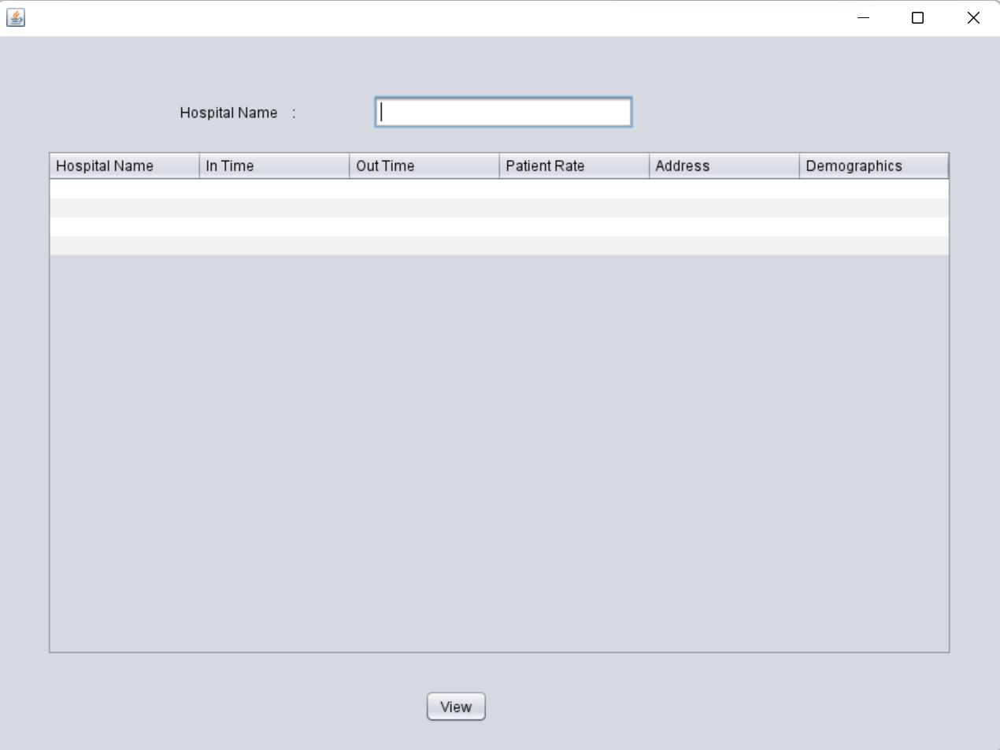

import java.sql.Connection;

import java.sql.DriverManager;

import java.sql.ResultSet;

import java.sql.Statement;

import javax.swing.JFrame;

import javax.swing.JOptionPane;

import javax.swing.table.DefaultTableModel;

/*

* Click nbfs://nbhost/SystemFileSystem/Templates/Licenses/license-default.txt to change this license

* Click nbfs://nbhost/SystemFileSystem/Templates/GUIForms/JFrame.java to edit this template

*/

/**

*

* @author sai suman

*/

public class HospitalUI extends javax.swing.JFrame {

/**

* Creates new form HospitalUI

*/

public HospitalUI() {

initComponents();

}

/**

* This method is called from within the constructor to initialize the form.

* WARNING: Do NOT modify this code. The content of this method is always

* regenerated by the Form Editor.

*/

@SuppressWarnings("unchecked")

// <editor-fold defaultstate="collapsed" desc="Generated Code">

private void initComponents() {

popupMenu1 = new java.awt.PopupMenu();

jPasswordField1 = new javax.swing.JPasswordField();

jLabel1 = new javax.swing.JLabel();

jButton1 = new javax.swing.JButton();

jTextField1 = new javax.swing.JTextField();

jScrollPane1 = new javax.swing.JScrollPane();

jTable1 = new javax.swing.JTable();

popupMenu1.setLabel("popupMenu1");

jPasswordField1.setText("jPasswordField1");

setDefaultCloseOperation(javax.swing.WindowConstants.EXIT_ON_CLOSE);

jLabel1.setText("Hospital Name :");

jButton1.setText("View");

jButton1.addActionListener(new java.awt.event.ActionListener() {

public void actionPerformed(java.awt.event.ActionEvent evt) {

jButton1ActionPerformed(evt);

}

});

jTable1.setModel(new javax.swing.table.DefaultTableModel(

new Object [][] {

{null, null, null, null, null, null},

{null, null, null, null, null, null},

{null, null, null, null, null, null},

{null, null, null, null, null, null}

},

new String [] {

"Hospital Name", "In Time", "Out Time", "Patient Rate", "Address", "Demographics"

}

) {

Class[] types = new Class [] {

java.lang.String.class, java.lang.String.class, java.lang.String.class, java.lang.String.class, java.lang.String.class, java.lang.String.class

};

public Class getColumnClass(int columnIndex) {

return types [columnIndex];

}

});

jScrollPane1.setViewportView(jTable1);

javax.swing.GroupLayout layout = new javax.swing.GroupLayout(getContentPane());

getContentPane().setLayout(layout);

layout.setHorizontalGroup(

layout.createParallelGroup(javax.swing.GroupLayout.Alignment.LEADING)

.addGroup(layout.createSequentialGroup()

.addGroup(layout.createParallelGroup(javax.swing.GroupLayout.Alignment.LEADING)

.addGroup(layout.createSequentialGroup()

.addGap(155, 155, 155)

.addComponent(jLabel1)

.addGap(66, 66, 66)

.addComponent(jTextField1, javax.swing.GroupLayout.PREFERRED_SIZE, 220, javax.swing.GroupLayout.PREFERRED_SIZE))

.addGroup(layout.createSequentialGroup()

.addGap(42, 42, 42)

.addComponent(jScrollPane1, javax.swing.GroupLayout.PREFERRED_SIZE, 767, javax.swing.GroupLayout.PREFERRED_SIZE))

.addGroup(layout.createSequentialGroup()

.addGap(362, 362, 362)

.addComponent(jButton1)))

.addContainerGap(41, Short.MAX_VALUE))

);

layout.setVerticalGroup(

layout.createParallelGroup(javax.swing.GroupLayout.Alignment.LEADING)

.addGroup(layout.createSequentialGroup()

.addGap(50, 50, 50)

.addGroup(layout.createParallelGroup(javax.swing.GroupLayout.Alignment.BASELINE)

.addComponent(jLabel1)

.addComponent(jTextField1, javax.swing.GroupLayout.PREFERRED_SIZE, javax.swing.GroupLayout.DEFAULT_SIZE, javax.swing.GroupLayout.PREFERRED_SIZE))

.addGap(18, 18, 18)

.addComponent(jScrollPane1, javax.swing.GroupLayout.PREFERRED_SIZE, javax.swing.GroupLayout.DEFAULT_SIZE, javax.swing.GroupLayout.PREFERRED_SIZE)

.addPreferredGap(javax.swing.LayoutStyle.ComponentPlacement.RELATED, 29, Short.MAX_VALUE)

.addComponent(jButton1)

.addGap(25, 25, 25))

);

pack();

}// </editor-fold>

private void jButton1ActionPerformed(java.awt.event.ActionEvent evt) {

try

{

DriverManager.registerDriver(new oracle.jdbc.driver.OracleDriver());

// Connect to Oracle Database

Connection con = DriverManager.getConnection("jdbc:oracle:thin:@localhost:1521:XE" ,"jiba","jiba");

Statement statement = con.createStatement();

// Execute a SELECT query on Oracle Dummy DUAL Table. Useful for retrieving system values

// Enables us to retrieve values as if querying from a table

String query = "SELECT * FROM HOSPITAL WHERE hospitalname = '" + jTextField1.getText() +"'" ;

ResultSet rs = statement.executeQuery(query);

JOptionPane.showMessageDialog(new JFrame(), "Hospital Details", "INFORMATION", JOptionPane.INFORMATION_MESSAGE);

DefaultTableModel model = (DefaultTableModel) jTable1.getModel();

String hospitalname,intime,outtime,patientrate,address,demographics;

while(rs.next())

{

hospitalname = rs.getString(1);

intime = rs.getString(2);

outtime = rs.getString(3);

patientrate = rs.getString(4);

address = rs.getString(5);

demographics = rs.getString(6);

String d[] = {hospitalname,intime,outtime,patientrate,address,demographics};

model.addRow(d);

}

/*while(rs.next()) {

//Date currentDate = rs.getDate(1); // get first column returned

//System.out.println("Current Date from Oracle is : "+currentDate);

System.out.println(rs.getString("ID") + rs.getString("AADHAR"));

}*/

rs.close();

statement.close();

con.close();

}

catch(Exception e)

{

System.out.println(e);

}

}

/**

* @param args the command line arguments

*/

public static void main(String args[]) {

/* Set the Nimbus look and feel */

//<editor-fold defaultstate="collapsed" desc=" Look and feel setting code (optional) ">

/* If Nimbus (introduced in Java SE 6) is not available, stay with the default look and feel.

* For details see http://download.oracle.com/javase/tutorial/uiswing/lookandfeel/plaf.html

*/

try {

for (javax.swing.UIManager.LookAndFeelInfo info : javax.swing.UIManager.getInstalledLookAndFeels()) {

if ("Nimbus".equals(info.getName())) {

javax.swing.UIManager.setLookAndFeel(info.getClassName());

break;

}

}

} catch (ClassNotFoundException ex) {

java.util.logging.Logger.getLogger(HospitalUI.class.getName()).log(java.util.logging.Level.SEVERE, null, ex);

} catch (InstantiationException ex) {

java.util.logging.Logger.getLogger(HospitalUI.class.getName()).log(java.util.logging.Level.SEVERE, null, ex);

} catch (IllegalAccessException ex) {

java.util.logging.Logger.getLogger(HospitalUI.class.getName()).log(java.util.logging.Level.SEVERE, null, ex);

} catch (javax.swing.UnsupportedLookAndFeelException ex) {

java.util.logging.Logger.getLogger(HospitalUI.class.getName()).log(java.util.logging.Level.SEVERE, null, ex);

}

//</editor-fold>

/* Create and display the form */

java.awt.EventQueue.invokeLater(new Runnable() {

public void run() {

new HospitalUI().setVisible(true);

}

});

}

// Variables declaration - do not modify

private javax.swing.JButton jButton1;

private javax.swing.JLabel jLabel1;

private javax.swing.JPasswordField jPasswordField1;

private javax.swing.JScrollPane jScrollPane1;

private javax.swing.JTable jTable1;

private javax.swing.JTextField jTextField1;

private java.awt.PopupMenu popupMenu1;

// End of variables declaration

}

**GitHub Links and Folder Structure**

**Link:** [**https://github.com/VishnuVardhan008/College-Network-Hardware-Database.git**](https://github.com/VishnuVardhan008/College-Network-Hardware-Database.git)

**Folder Structure:**

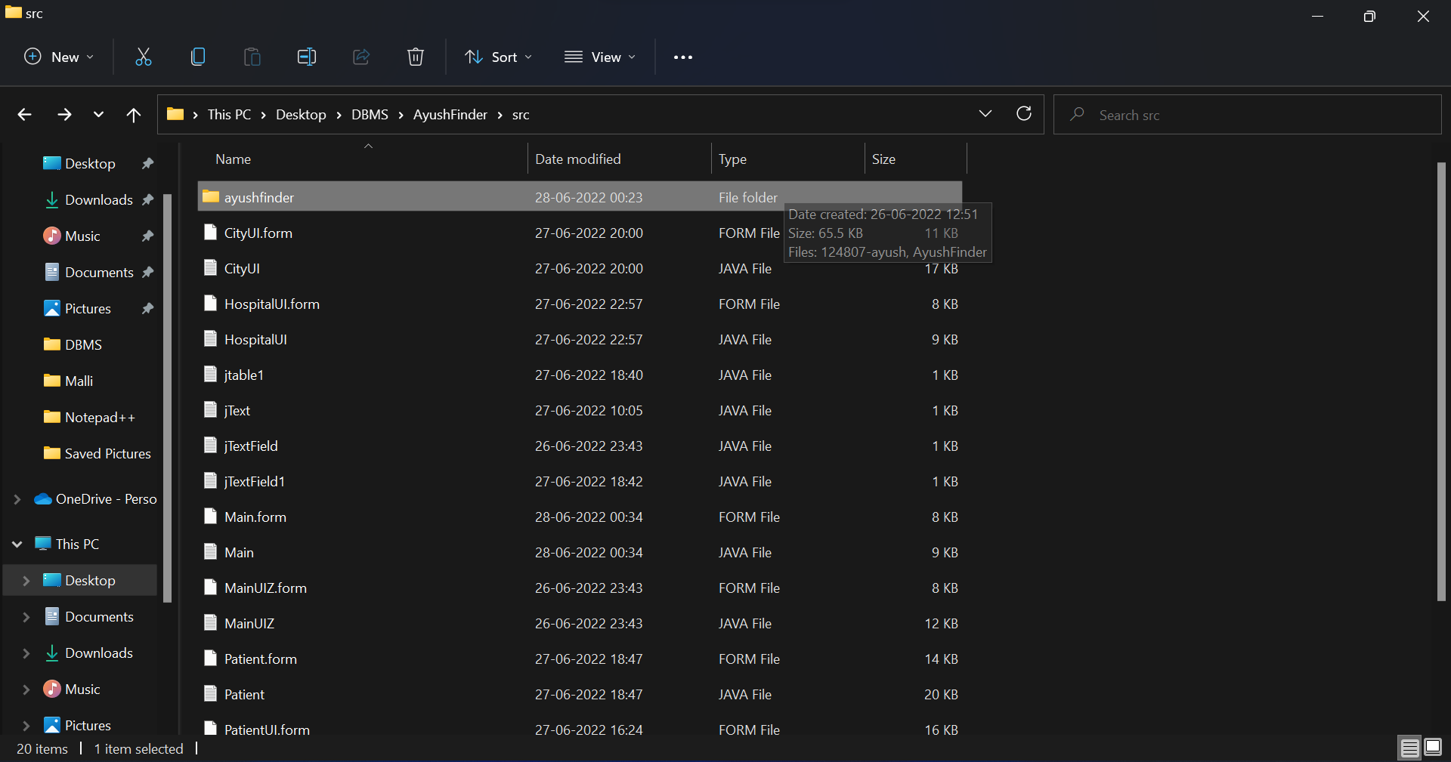

# TESTING

###### **Home page:**

In the home page user can find 4 buttons in which user can enter into the associated form .

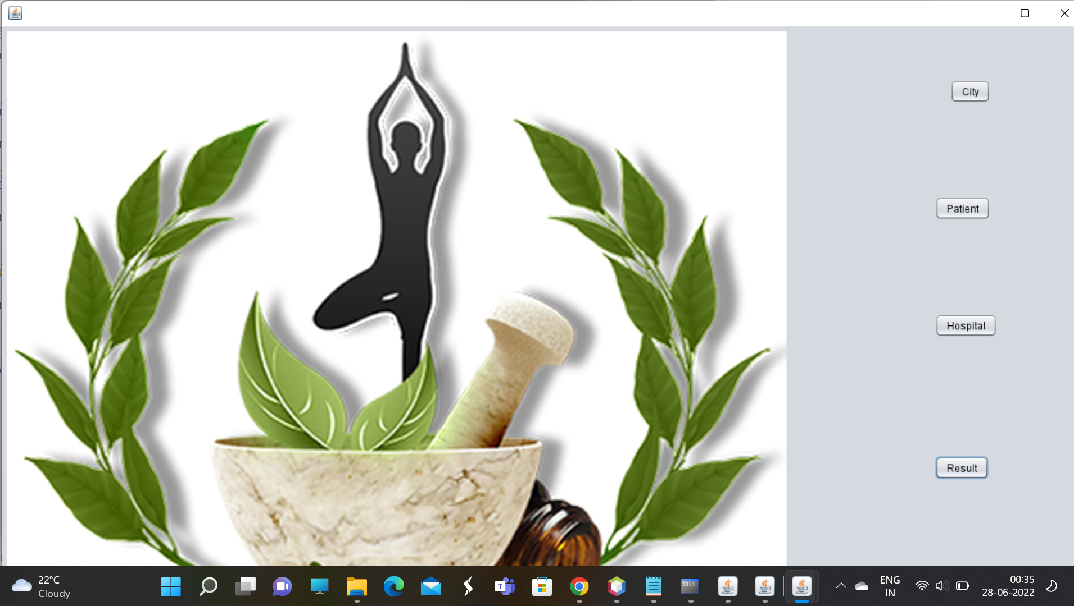

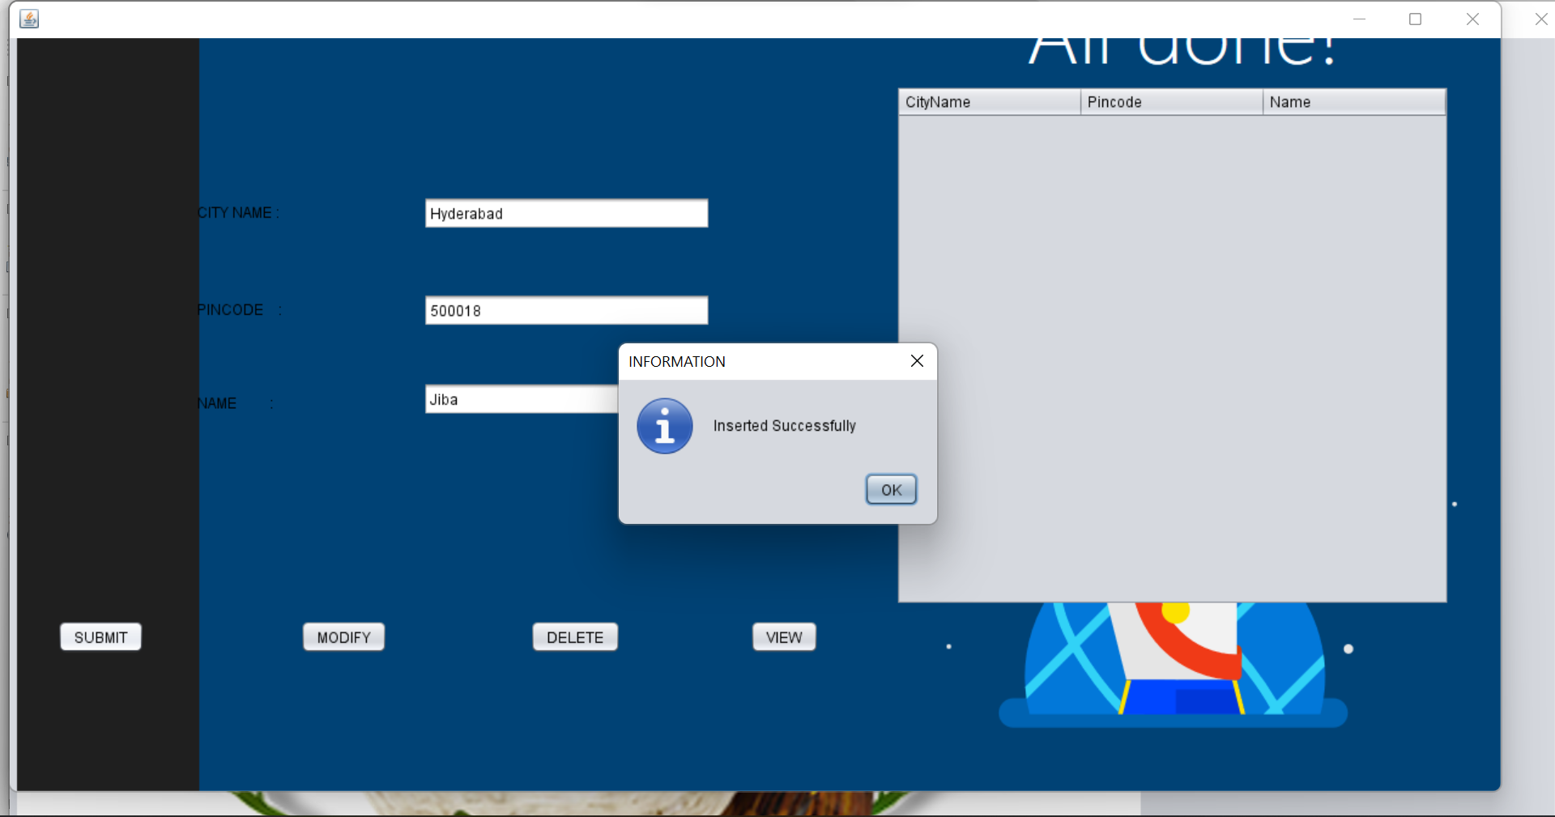

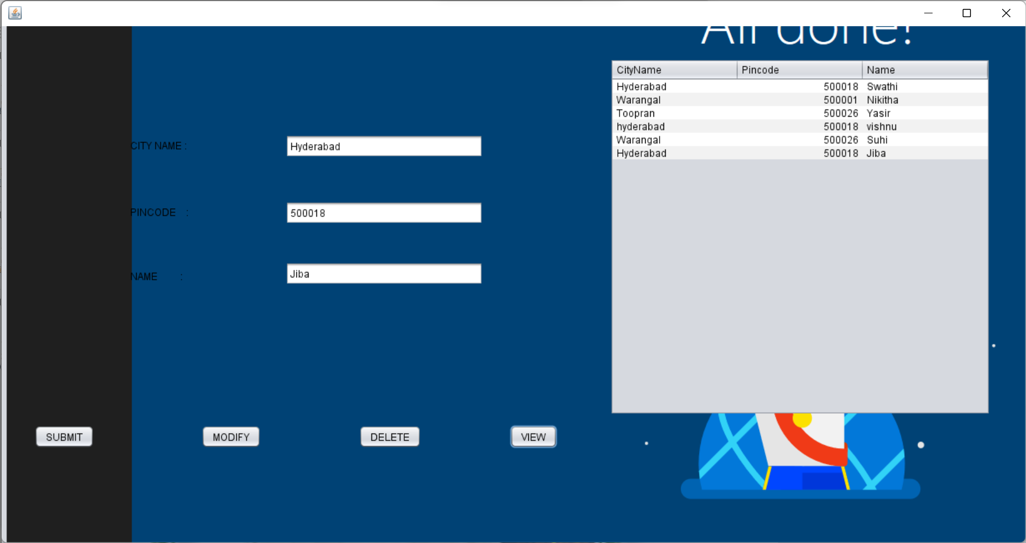

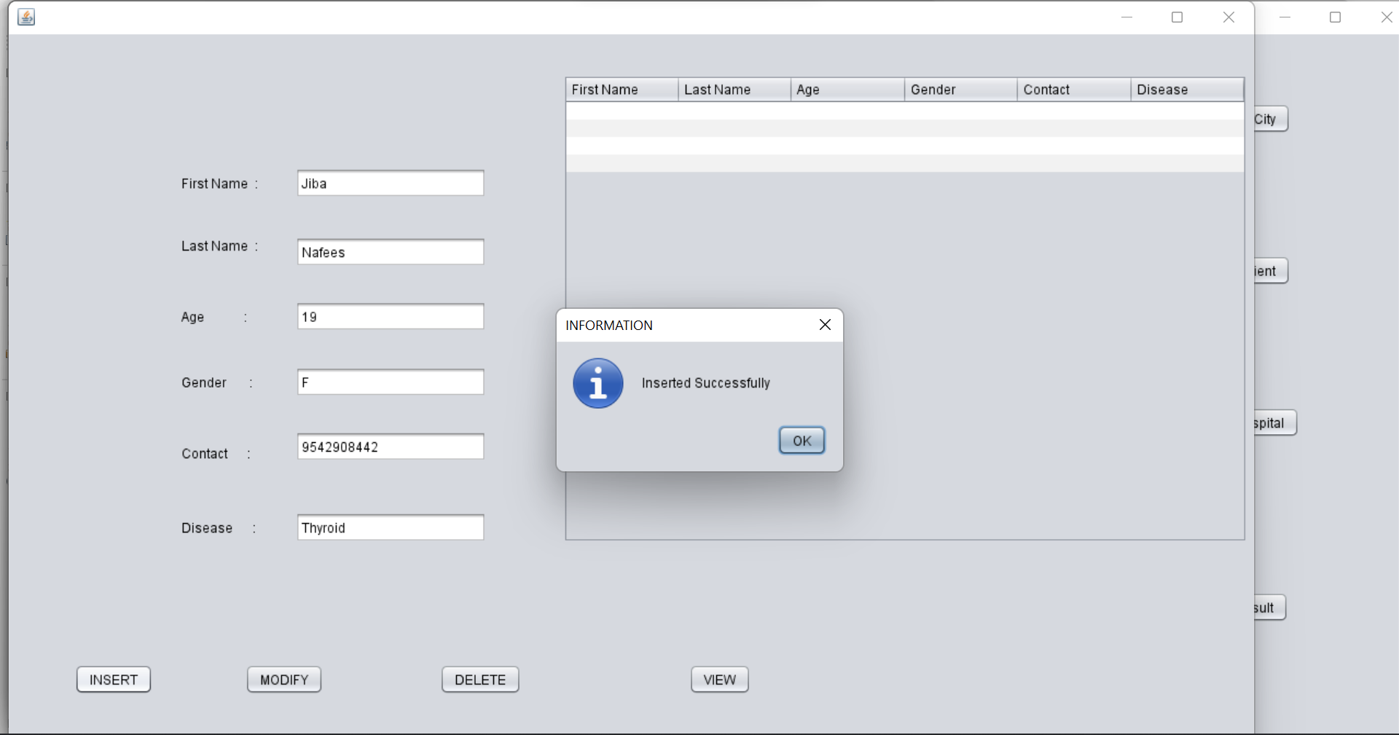

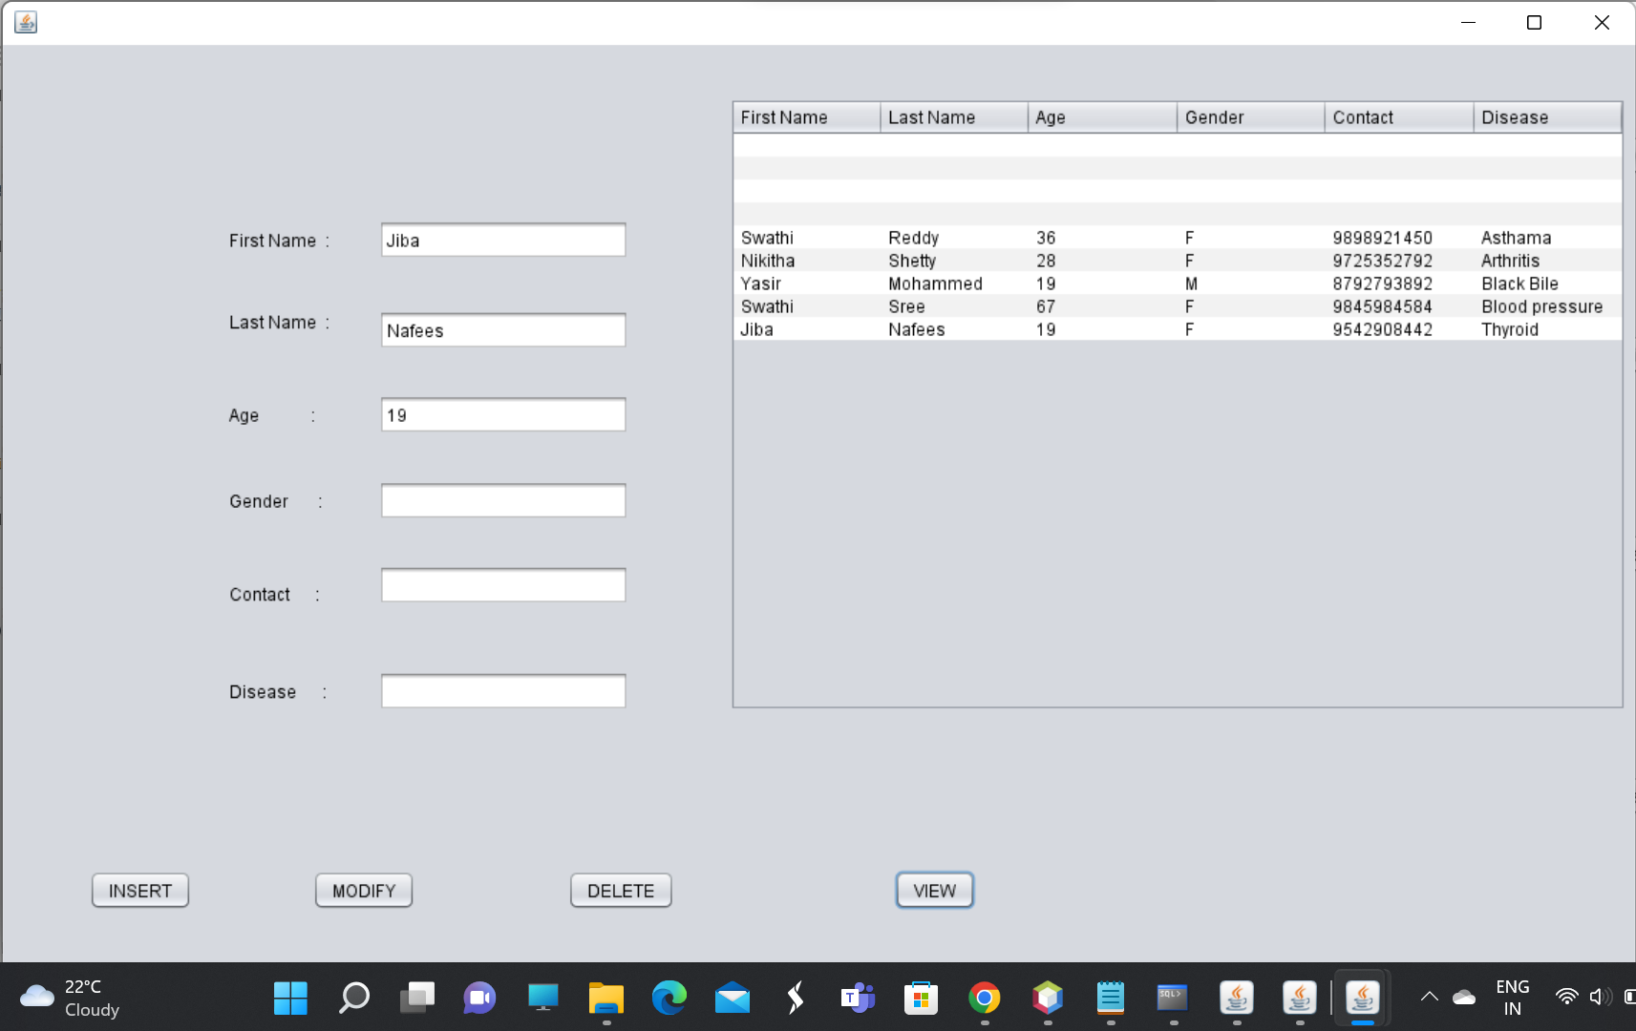

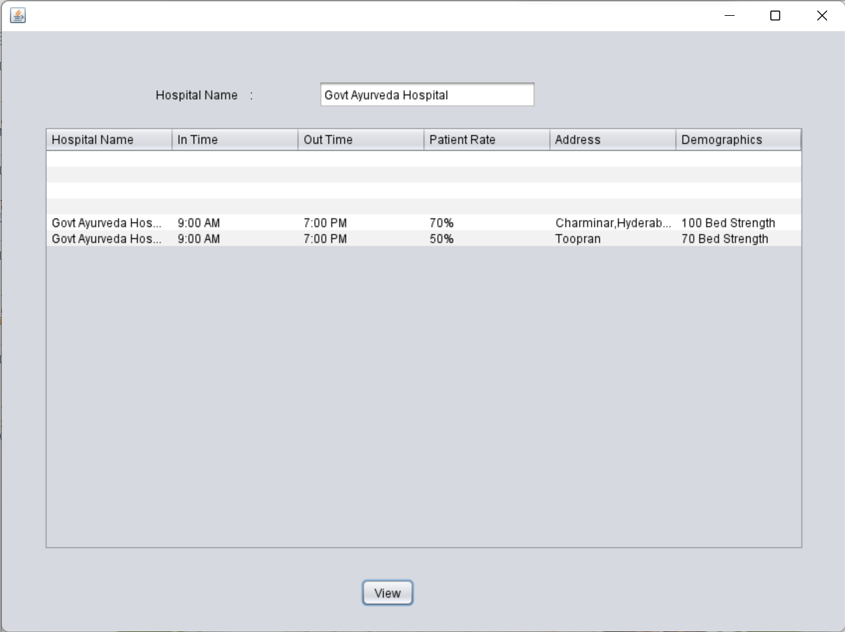

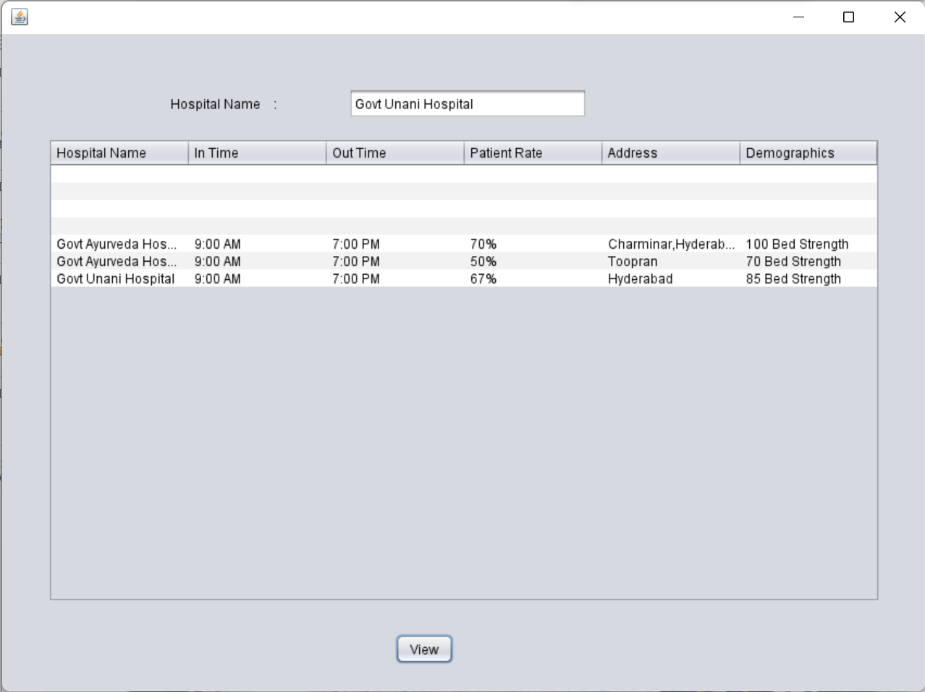

**RESULTS**

I have successfully completed the mini-project ***“Ayush Hospital Finder”*** .

## DISCUSSION AND FUTURE WORK

This project contains the basic information about Ayush Hospital Database . It has a very basic user interface. Future scope would be to make the UI more appealing by using graphics. One more feature would be to add login page to

this interface.

## REFERENCES

* <https://docs.oracle.com/javase/7/docs/api/>
* <https://www.javatpoint.com/java-swing>
* <https://stackoverflow.com/>